CMPE 315: Principles of VLSI Design
Lab Cover Page

Lab # : 5
Lab Title : Import VHDL, layout and LVS

Name : Nem Negash
Section : 1

Date Submitted : 10/25/2021

TA / Grader Use Only:

Late Submission Deduction (20% per day late):

Other Deductions:

Final Lab Grade:

Comments to student:

Table of Contents
Schematics, Layouts, and LVS outputs………………………………………………………………3
Inverter gate…………………………………………………………………………………….....3
And2 gate………...………………………………………………….……………………………..5
Or3 gate………………………………….………….……………………………………………..7
Xor2 gate…………………………………...……………………………………………………...9
Mux_2_1 gate…………………………..……………..………………..……………………..…11
Mux_4_1 gate…...………………...………………………...…………..………..…..………….13
Mux_4_bit gate…...………………………………...……….………..………………..……..….15
Adder1 gate……..…………………………...….…..………………………………..…………..18
Adder4 gate……..…………………………………….……...…………………………………..20
Alu_4 gate……………………………………….……………………………………………….22

Schematics, Layouts, and LVS outputs
- Inverter gate
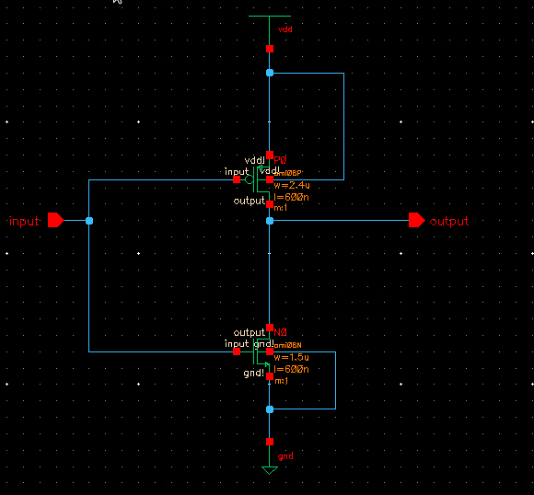
Figure 1: Inverter gate schematic

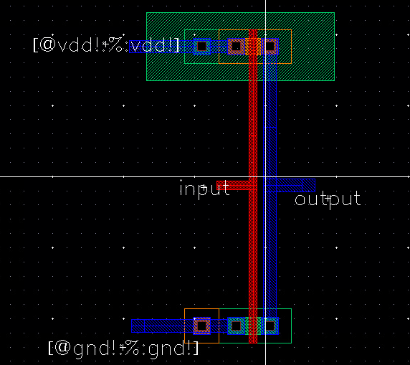
Figure 2: Inverter gate layout
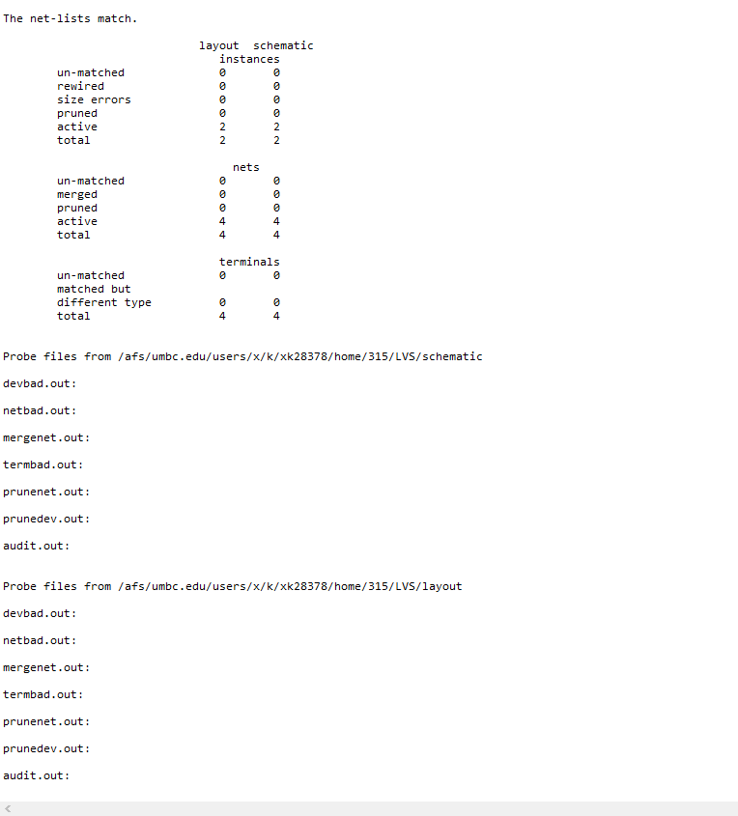
Figure 3: Inverter gate LVS output

- And2 gate
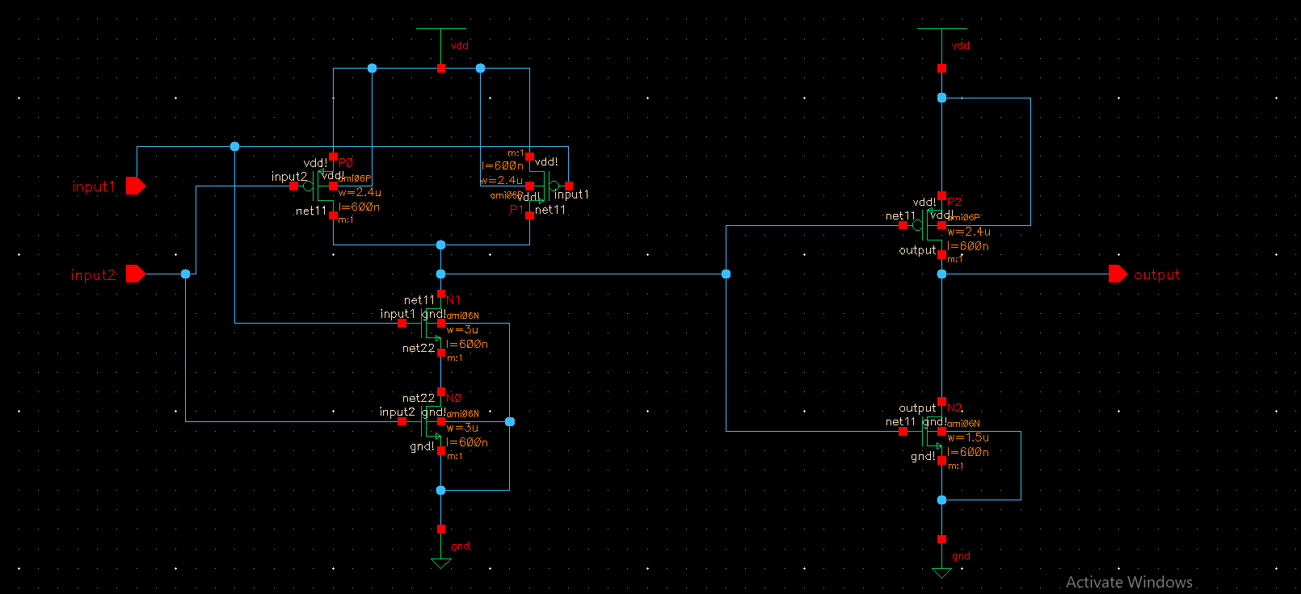
Figure 4: And2 gate schematic

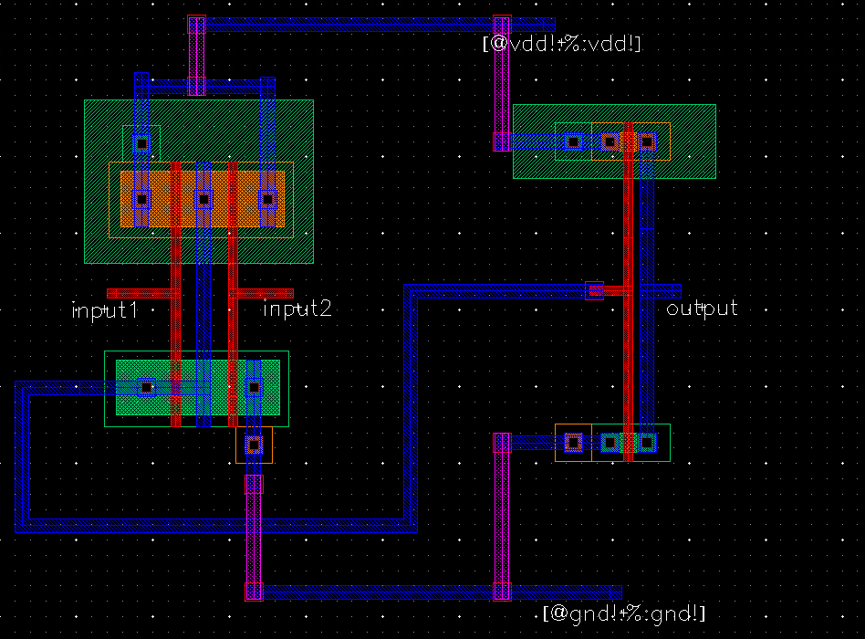
Figure 5: And2 gate layout
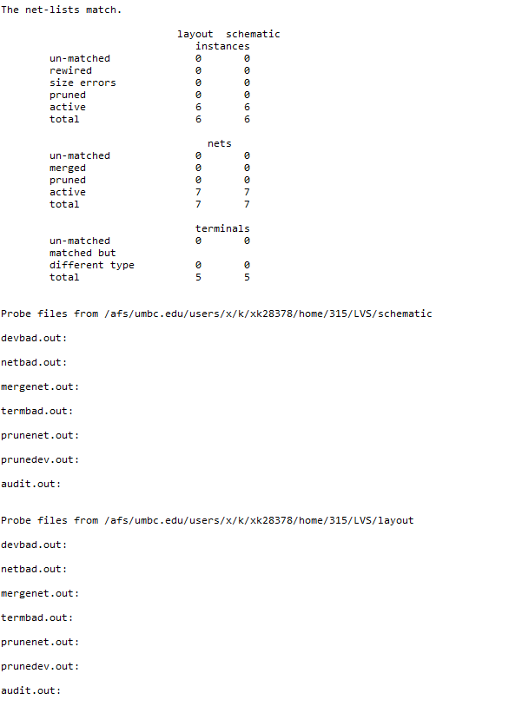
Figure 6: And2 gate LVS output

- Or3 gate
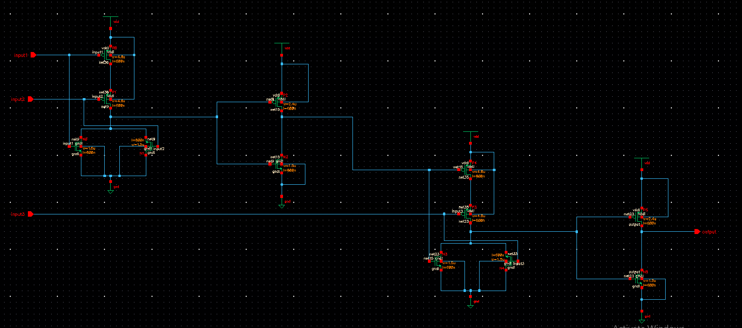
Figure 7: Or3 gate schematic

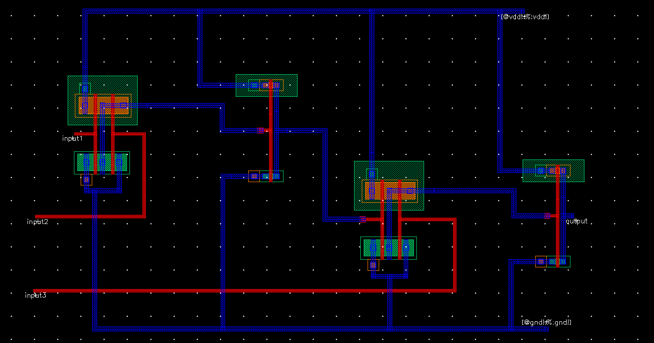
Figure 8: Or3 gate layout
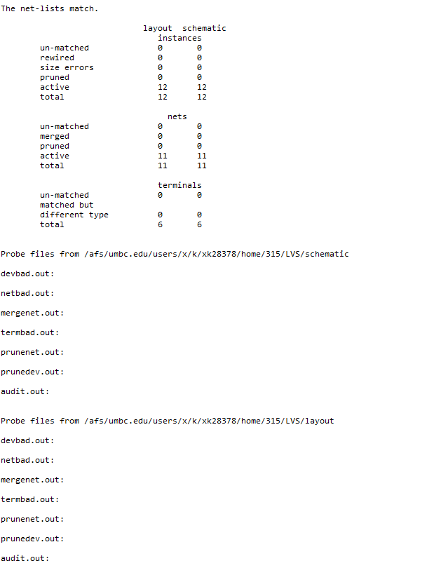
Figure 9: Or3 gate LVS output

- Xor2 gate
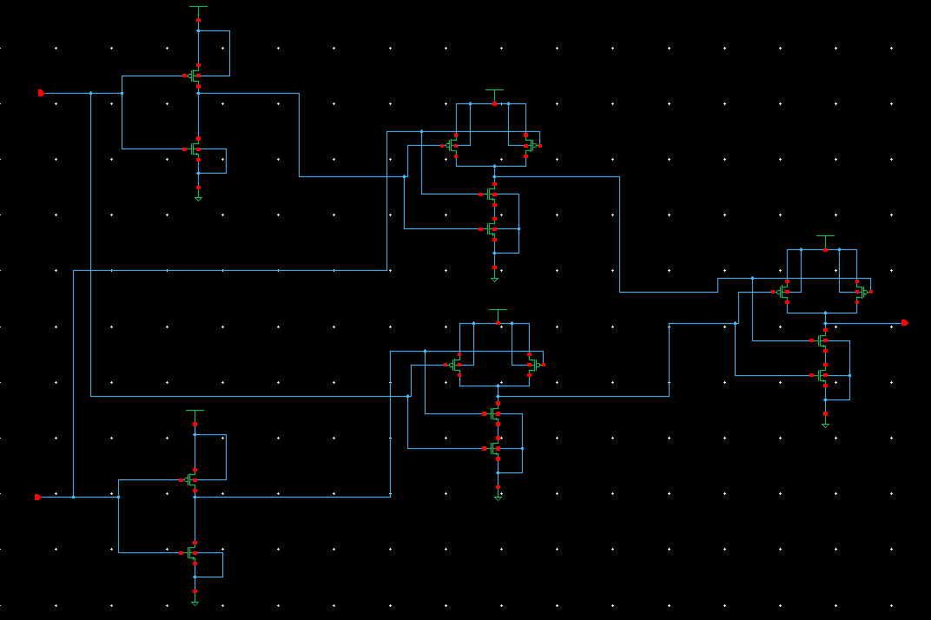
Figure 10: Xor2 gate schematic
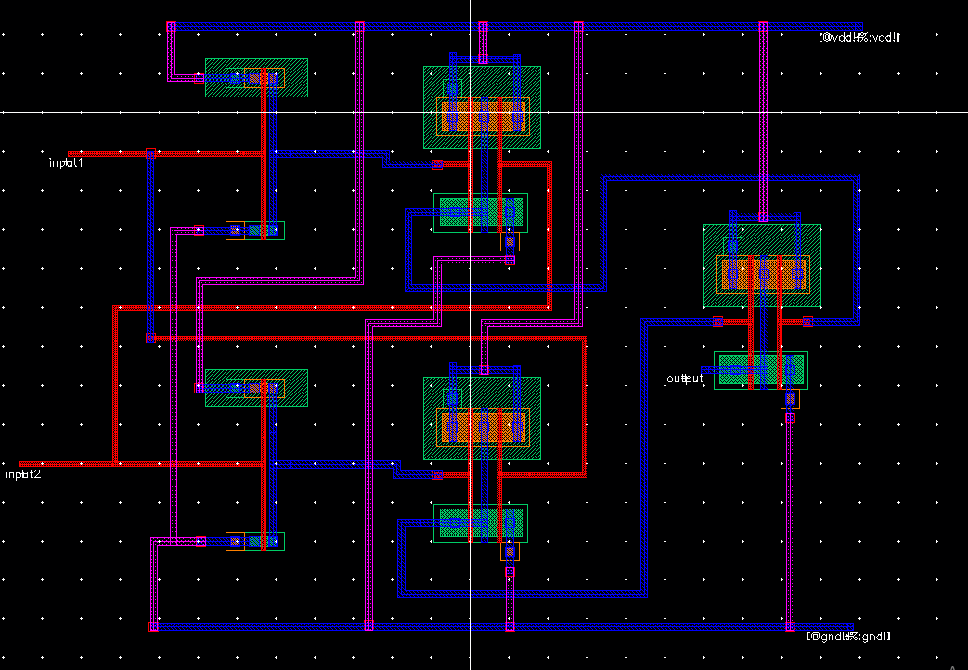
Figure 11: Xor2 gate layout
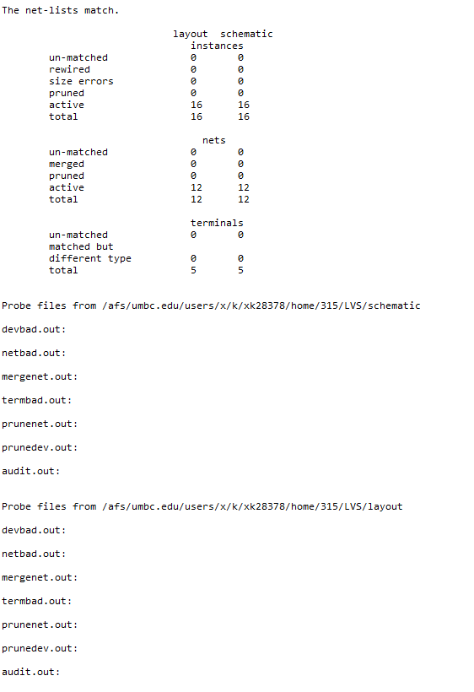
Figure 12: Xor2 gate LVS output
- Mux_2_1 gate
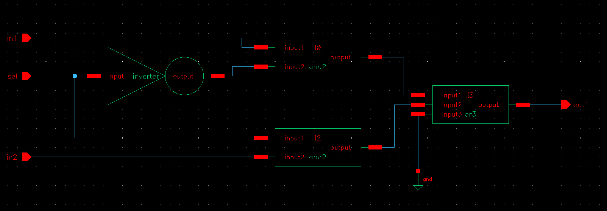
Figure 13: Mux_2_1 gate schematic

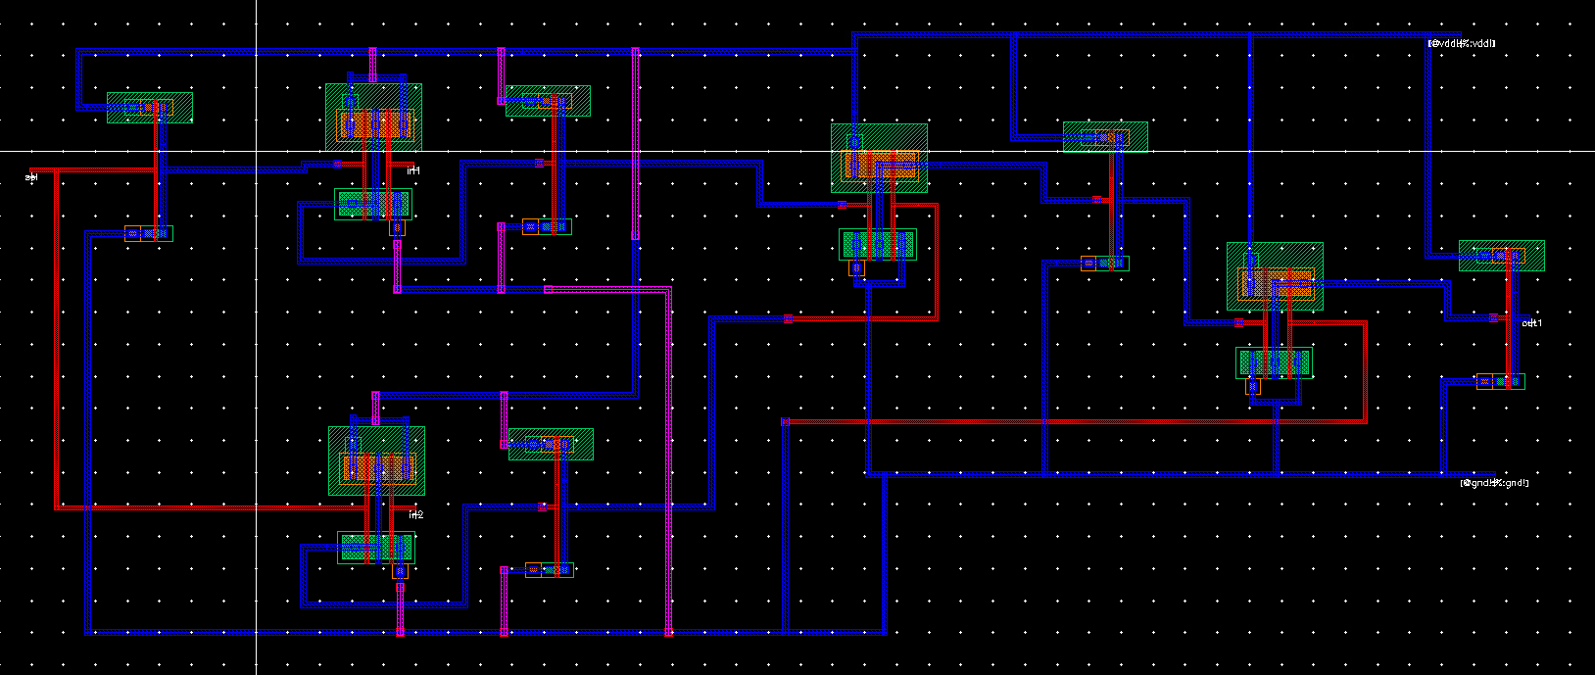
Figure 14: Mux_2_1 gate layout
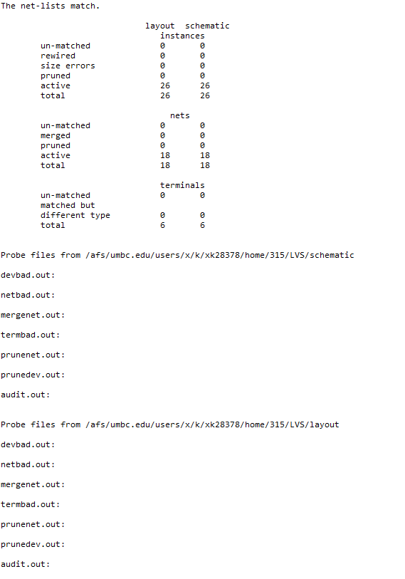
Figure 15: Mux_2_1 gate LVS output

- Mux_4_1 gate

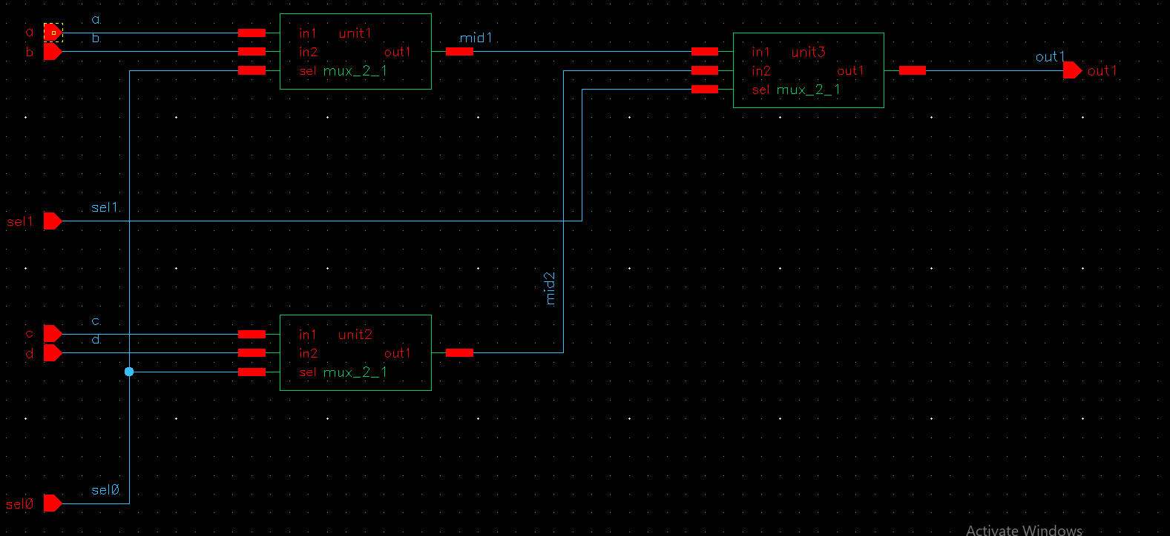
Figure 16: Mux_4_1 gate schematic

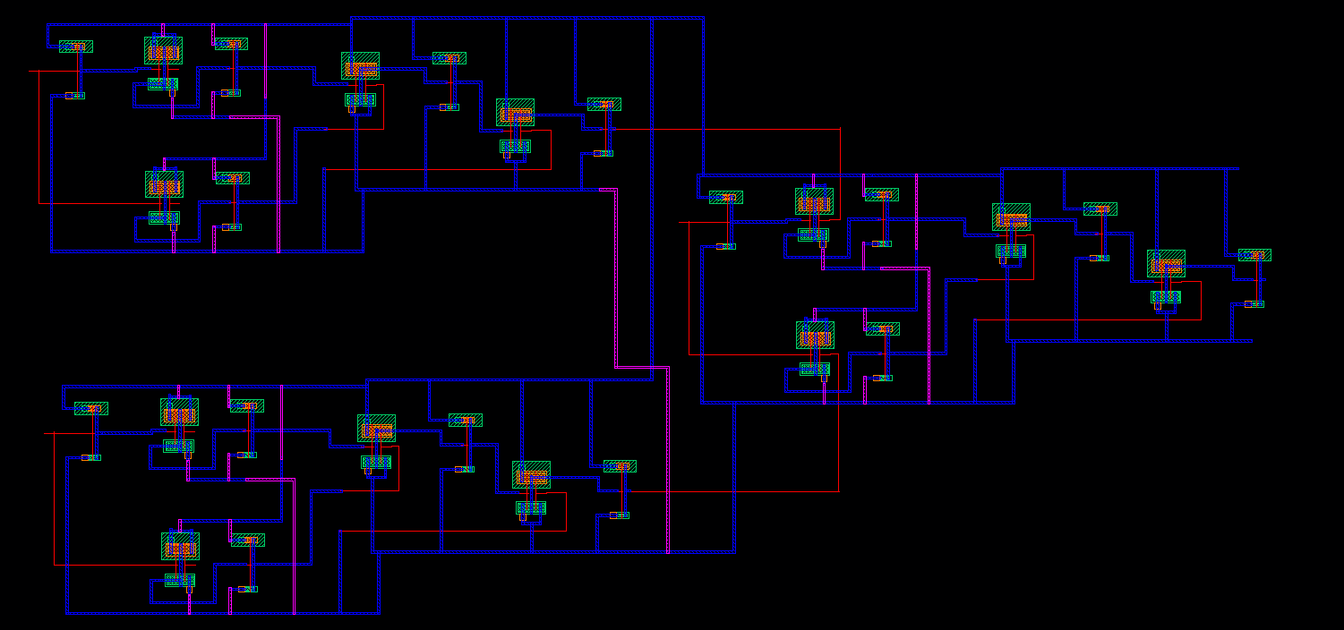
Figure 17: Mux_4_1 gate layout
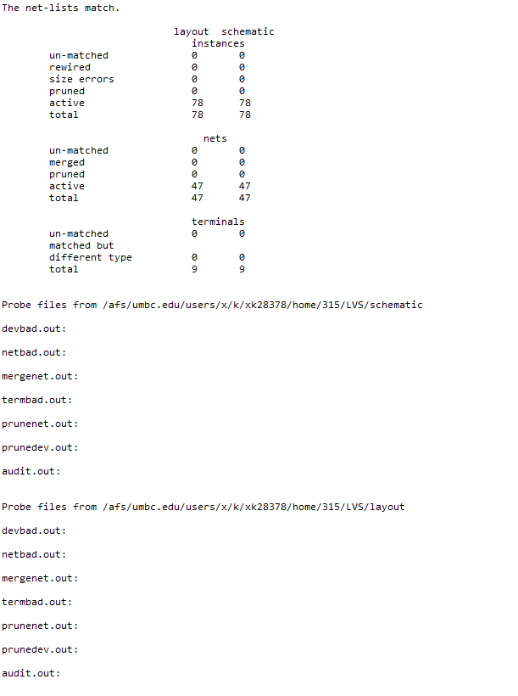
Figure 18: Mux_4_1 gate LVS output

- Mux_4_bit gate
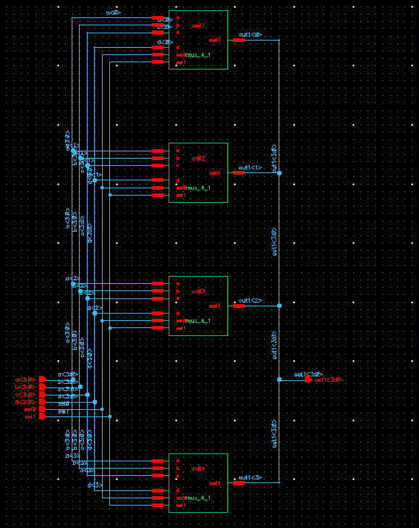
Figure 19: Mux_4_bit gate schematic

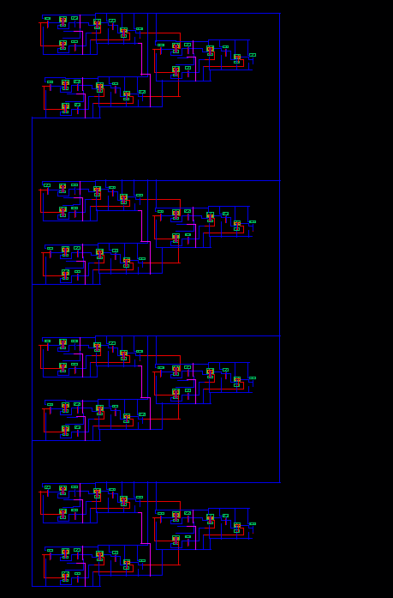
Figure 20: Mux_4_bit gate layout
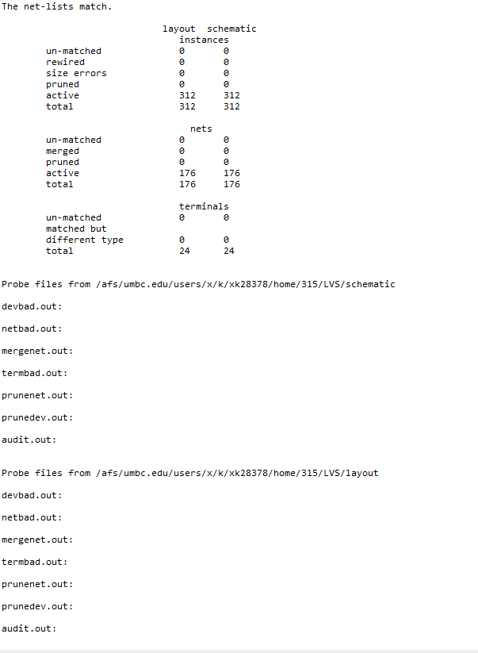
Figure 21: Mux_4_bit gate LVS output

- Adder1
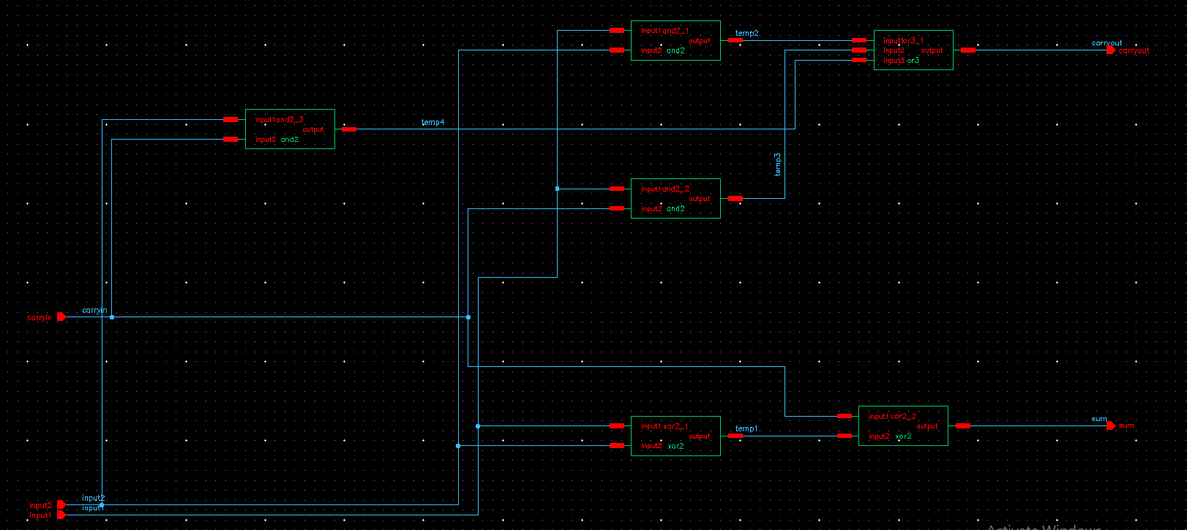
Figure 22: Adder1 gate schematic

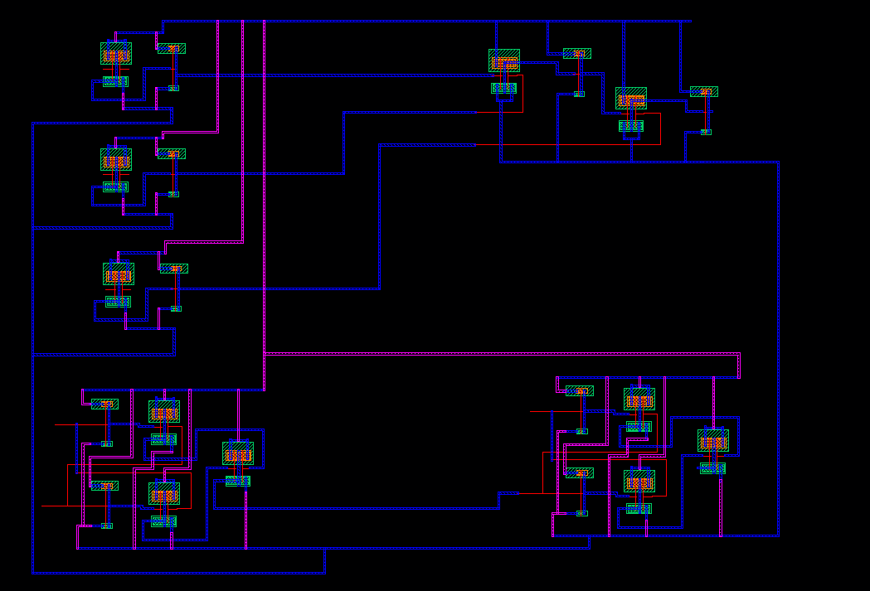
Figure 23: Adder1 gate layout
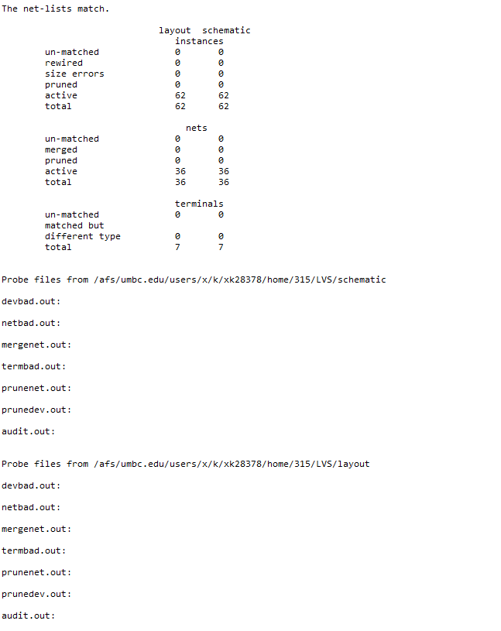
Figure 24: Adder1 gate LVS schematic

- Adder4

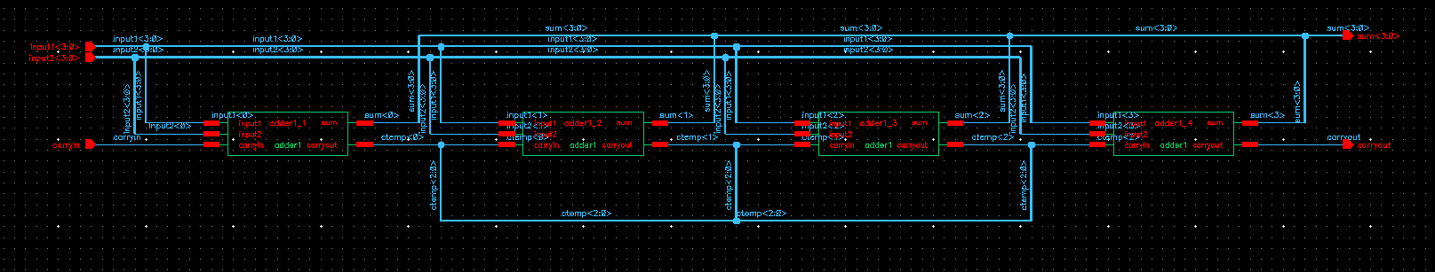
Figure 25: Adder4 gate schematic
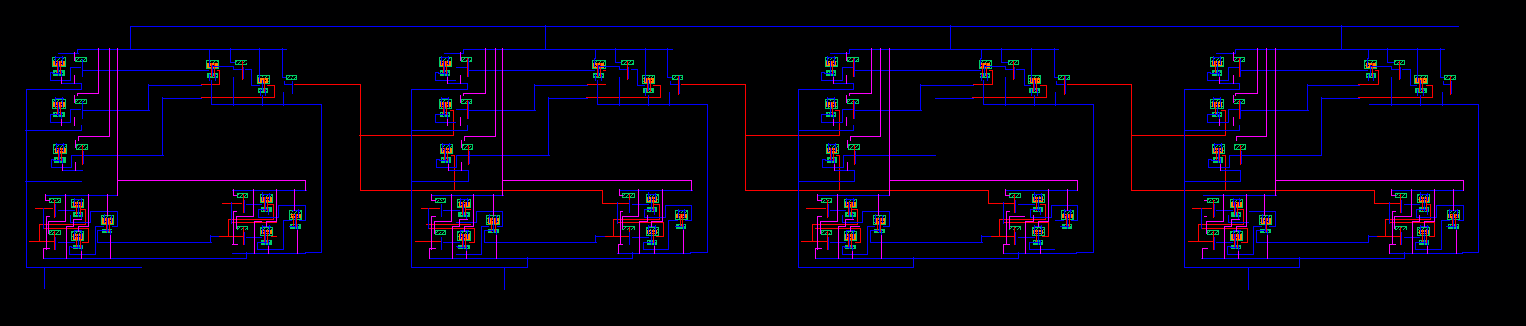
Figure 26: Adder gate layout
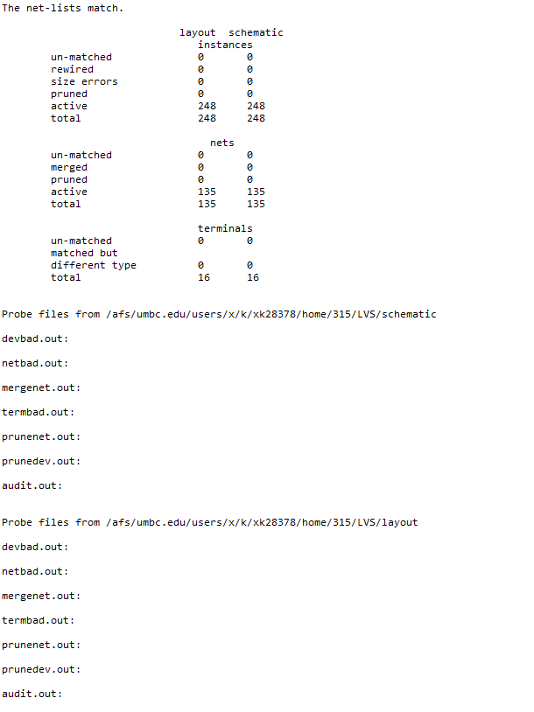
Figure 27: Adder4 gate LVS output

- Alu_4
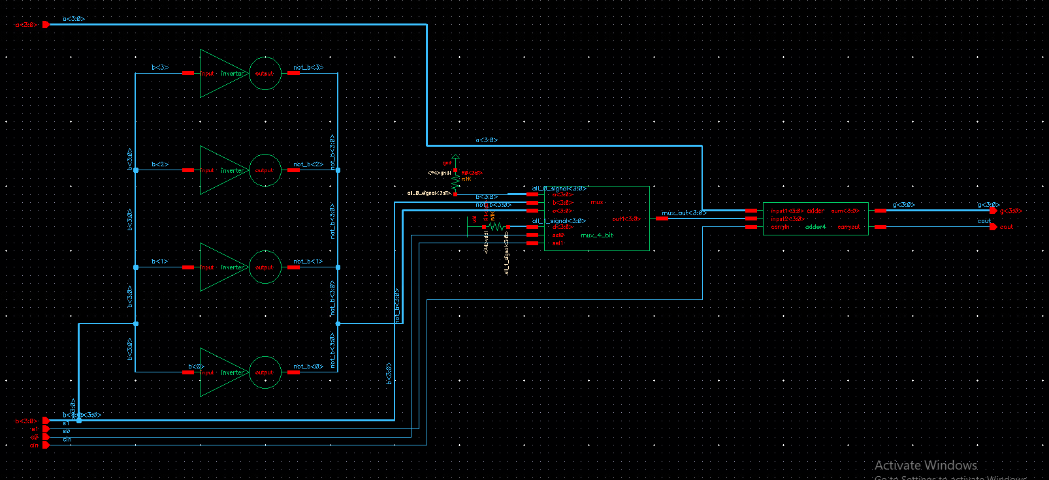
Figure 28: Alu_4 gate schematic

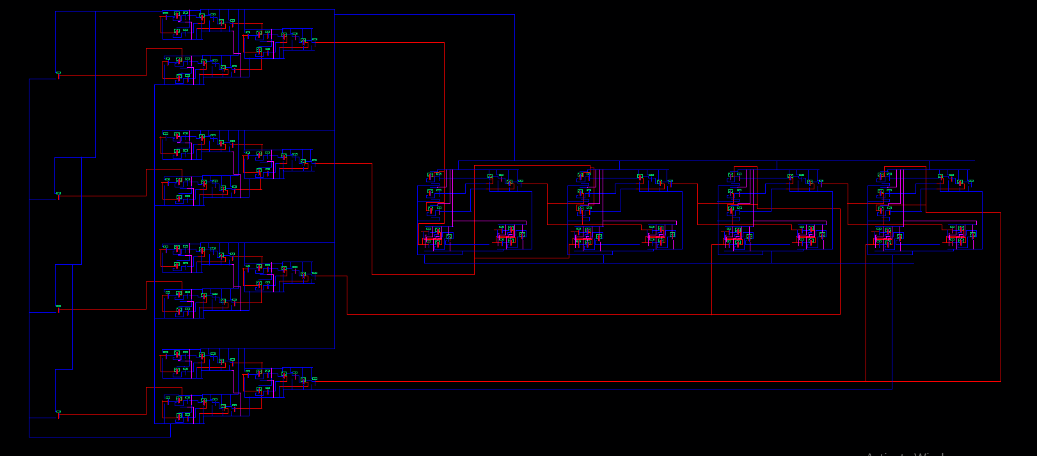
Figure 29: Alu_4 gate layout

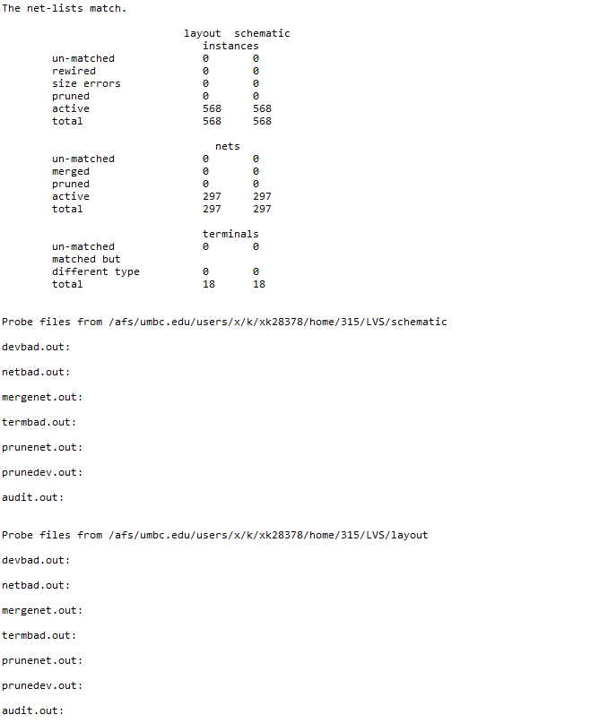
Figure 30: Alu_4 gate LVS output

